1. A picture containing text

   Description automatically generated  
   
2. 
3. We will use the followings:
   1. Intellij IDE.
   2. Confluent Kafka Community Edition.
4. We already saw in the previous lecture about how to create 3-Node Kafka Cluster.   
   The configuration created 3 log files one for each node (Broker) in the c:\tmp directory as follows:  
   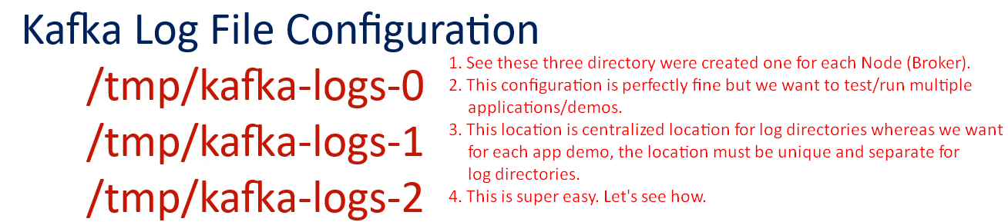  
   **What we will be the approach?**

Actually, we want the same cluster installation for all examples/demos. It means when running Kafka Cluster for different demo apps, log files must not be overlapped.   
So, we will create a separate Data Dir **c:\tem\kafka-logs-0** for each example.  
 **How to do this?**

Change the **Data Log Directory** to the current directory.  
Every time you start Kafka Cluster from your IDE, it will create new log in the current Directory of the project.   
It works like running a separate Kafka Cluster for each example.  
Let’s see how to do this:

* 1. 
  2. 
  3. 
  4. 
  5. **Setting Environment variable** “KAKFA_HOME”
  6. 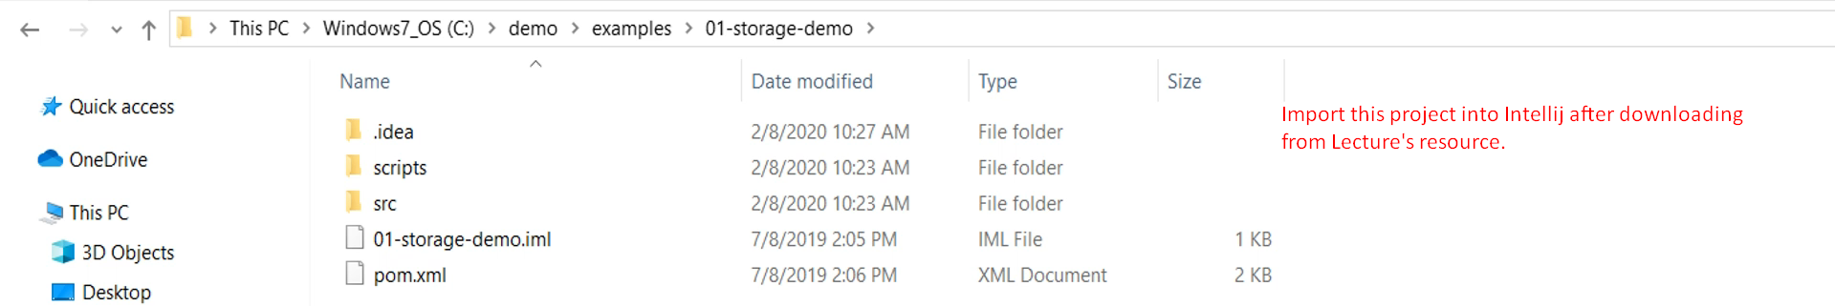
  7. Graphical user interface

     Description automatically generated
  8. 
  9. Graphical user interface, application

     Description automatically generated
  10. 
  11. 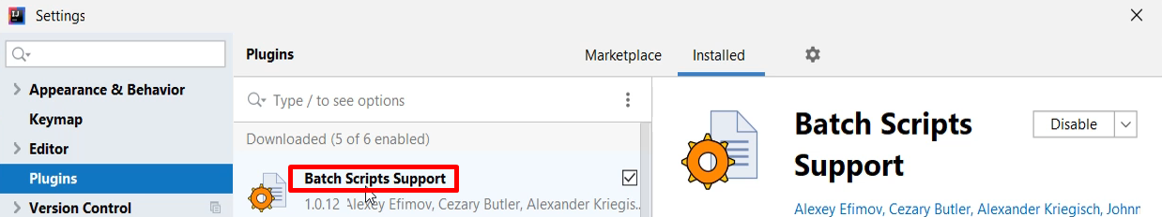
  12. 
  13. A picture containing graphical user interface

      Description automatically generated  
      When we start another project, the log files of the other project will remain isolated in that project itself.
  14. 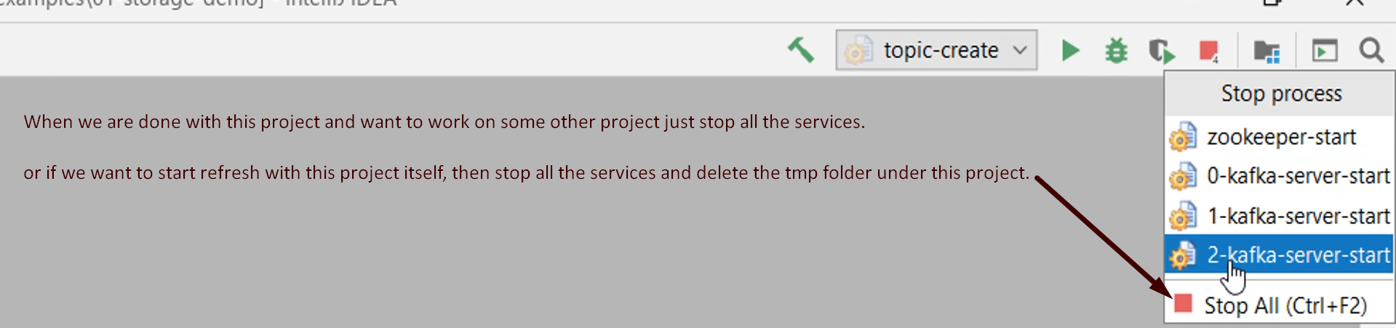

1. To make our life easy when demoing different apps with Kafka Configuration, we’re just doing two things.
   1. Setting **KAKFA_HOME** environment variable.
   2. Having separate scripts folder to run zookeeper, servers, topic under the project’s root directory itself.
   3. Most important: Setting **log Dir** for each project separately under the project itself.   
      This last step is the most important step. 😊